**The code was written using python in visual studio code. I created a folder in vscode then created venv environment then selecting python 3.9.13 venv as interpreter path then using pip command to download all the libraries before running the code.**

**you can run the code also with python version 3.12.1. just load the libraries and run the code without using venv environment.**

**The code I provided is in python notebook form.**

**Make sure that the name of the dataset folder and files inside it are as in the picture below.**

**To remove the duplicate images run the “delete duplicate” code**

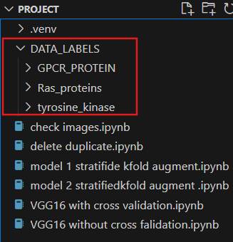

**Extensions in VScode**

